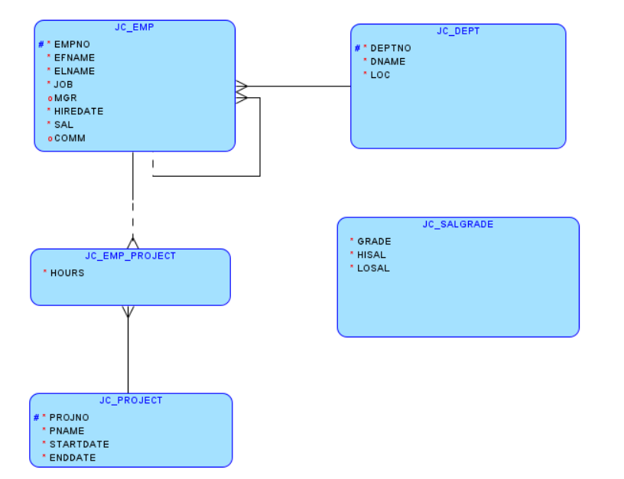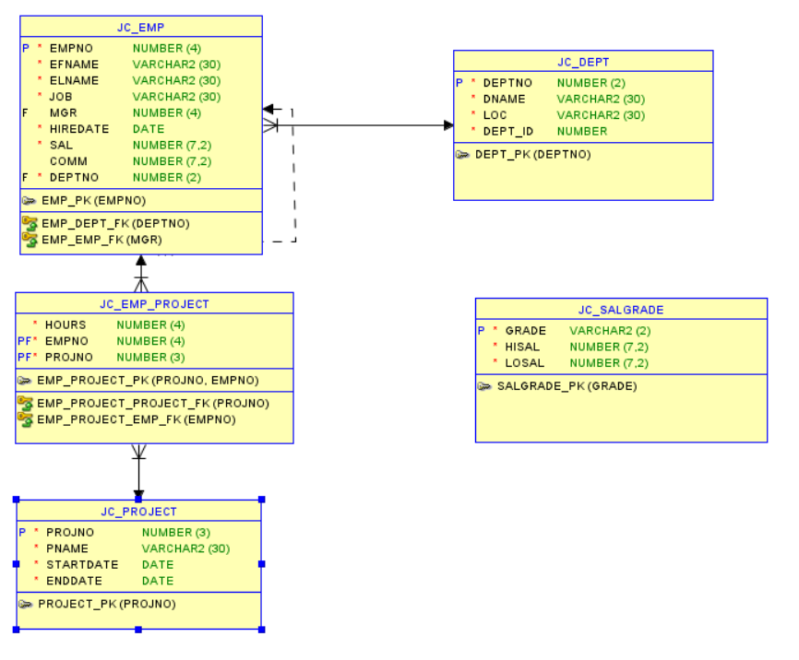

I have learned how to create a logical model and then convert this logical model to a relational model. After renaming the foreign kay column to the same column of primary key of the referenced table, I can generate the DDL script from the relational model.